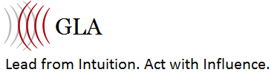

Confidential Student Questionnaire
Welcome to Gutsy Leadership Academy, your training resource for taking ACTION and IMPLEMENTING consistently to own your authority, lead without asking for permission and confidently communicate your expert value as a LEADER OF INFLUENCE!

Thank you for leading from your GUT and making a powerful investment in YOU. An investment in you is an investment in those you are meant to serve, your purpose, your spirit.

This confidential clarity questionnaire is meant for you and for me, so I may support you in your shoes. Please give yourself a quiet space to answer each question fully. This is just as much for you, as it is for us to help you create BIG results in your career or business this year. Consider lighting a candle, meditating while listening to your intuition and what comes up for you. It’s only when you carve out alone time, that you can have clear vision. Please submit this form to School@InRShoes.com.

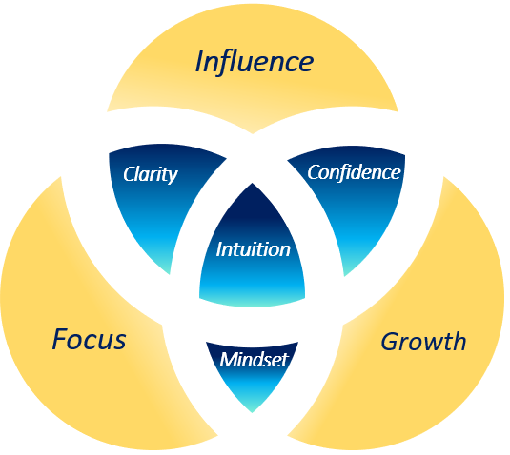

Please List Your Full Contact Information

Today's Date: Phone:

Name: Mobile Phone:

Street Address: E-Mail:

City/Town: State/Province:

Zip Code: Country:

Company Name: Website:

What is your birthday? [Month and Day]

How did you hear about In Our Shoes?
Please highlight which of the following goals most reflects where you want to be:

I want to:
- Advance my Career, Fast-path to a New Position.
- Change how I am perceived as a professional expert and leader in my field.
- Move into a more Senior-level or executive Position.
- Transition into Self-Employment; Get my Business off the ground.
- become a trainer, author or a coach, package my solutions/system serving others.
- other:

Why do you feel this program is right for you right now?

What is the nature of your work or business; what do you do for a living? (one sentence is sufficient)

The first 90 days: List 3 short-term goals you would like to work on with measurable results for each. Keep these realistic but a bit of a stretch for you.
1.

2.

3.

What have you done so far to self-promote yourself, reach your BIG career goals and increase your income, raise your fulfilment in your expertise, including what worked and what didn’t?

What has held you back or slowed your progress up to now (knowledge of industry/market, competition, resources, network, confidence in self or project, negative self-talk, negative community)?

What is the biggest opportunity/resource that you’re not taking advantage of?

Please list below all the things that you want to improve, achieve, master or change about your career over the next year.

Thanks for filling this out in its entirety. Doing so will create even better results for you. I am incredibly excited to begin working with you! ☺


Submission

Please email this form (in Word format) to: school@inrshoes.com. Let us know the best day and times to contact you in the next week and your local time zone.

